**Iaas Paas Saas**

Cloud computing has three main cloud service models: IaaS (infrastructure as a service), PaaS (platform as a service), and SaaS (software as a service). You might also hear IaaS, PaaS, and SaaS called cloud service offerings or cloud computing categories, but all of these terms refer to how you use the cloud in your organization and the degree of management you’re responsible for in your cloud environments.

In addition to these three broad categories, you may also come across other types of cloud services that incorporate other technologies, such as containers. For example, the rising adoption of containers and microservices architectures has led to the emergence of CaaS (containers as a service).

“As a service” typically means that the service model is offered by a third party in the cloud. In other words, you don’t have to purchase, manage, or use any hardware, software, tools, or applications from an on-premises data centre. Instead, you can simply pay a subscription or pay based on consumption (pay-as-you-go) to access what you need on demand via an internet connection.

**IaaS**

Infrastructure as a service, or IaaS, delivers on-demand infrastructure resources to organizations via the cloud, such as compute, storage, networking, and virtualization. Customers don’t have to manage, maintain, or update their own data centre infrastructure, but are responsible for the operating system, middleware, virtual machines, and any apps or data.

**PaaS**

Platform as a service, or PaaS, delivers and manages all the hardware and software resources to develop applications through the cloud. Developers and IT operations teams can use PaaS to develop, run, and manage applications without having to build and maintain the infrastructure or platform on their own. Customers still have to write the code and manage their data and applications, but the environment to build and deploy apps is managed and maintained by the cloud service provider.

**SaaS**

Software as a service, or SaaS, provides the entire application stack, delivering an entire cloud-based application that customers can access and use. SaaS products are completely managed by the service provider and come ready to use, including all updates, bug fixes, and overall maintenance. Most SaaS applications are accessed directly through a web browser, which means customers don’t have to download or install anything on their devices.

**Key differences between cloud IaaS, PaaS, SaaS, and CaaS**

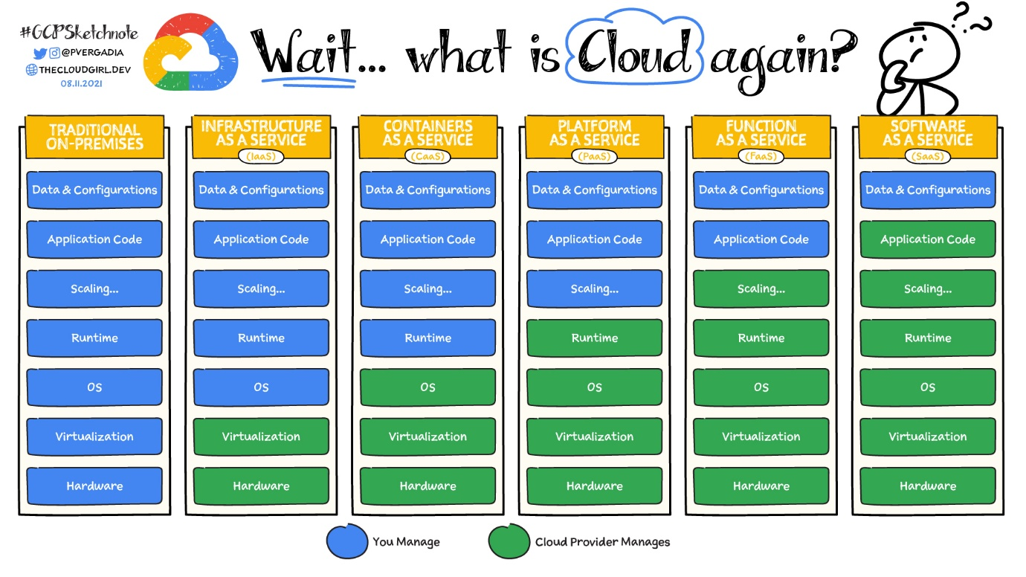

Understanding the difference between IaaS, PaaS, SaaS, and CaaS in cloud computing comes down to the level of control and responsibility. Each model offers an alternative to managing your own on-premises data centre, but the service provider will manage different elements in the computing stack depending on which type you choose.

To understand cloud and the different models to choose from, it can help to think about it in terms of housing:

* **On-premises:** If you decide to build your house from scratch, you do everything yourself. You’ll need to source the raw materials and tools, put everything together, and run to the store every time you need anything. This is similar to running an application on-premises, where you own everything from the hardware to your applications and scaling.
* **Infrastructure as a service:** If you are busy, you might consider hiring a contractor to do the work. You tell them how you want the house to look and how many rooms you want, and they take the instructions and build your home. IaaS works in a similar way for your applications. You rent the hardware to run your application on, but you are responsible for managing the OS, runtime, scale, and all the data. Example: Compute Engine
* **Platform as a service:** If you don’t want to worry about furnishing your living space, you can rent a furnished house. PaaS lets you bring your own code and deploy it but leaves the server management and scaling up to the cloud provider. Examples: App Engine, Cloud Run
* **Function as a service:** If you just need a small dedicated place to work away from your home, you can rent a desk in a coworking workspace. Similarly, FaaS allows you to build and deploy a small piece of code, or a function, that performs a specific task. The cloud provider adds scale if needed when a function executes. Example: Cloud Functions
* **Software as a service:** Now, imagine you move into a finished house (rented or purchased), but you have to pay for upkeep, such as cleaning or lawn care. SaaS is the same—you pay to use a complete application for a specific purpose that is managed, maintained, and secured by the cloud provider, but you are responsible for taking care of your own data. Example: Google Workspace

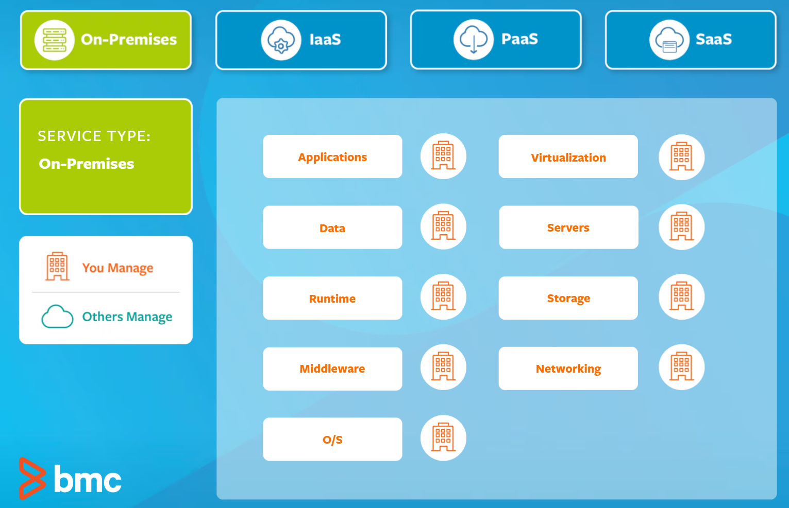

On-premises

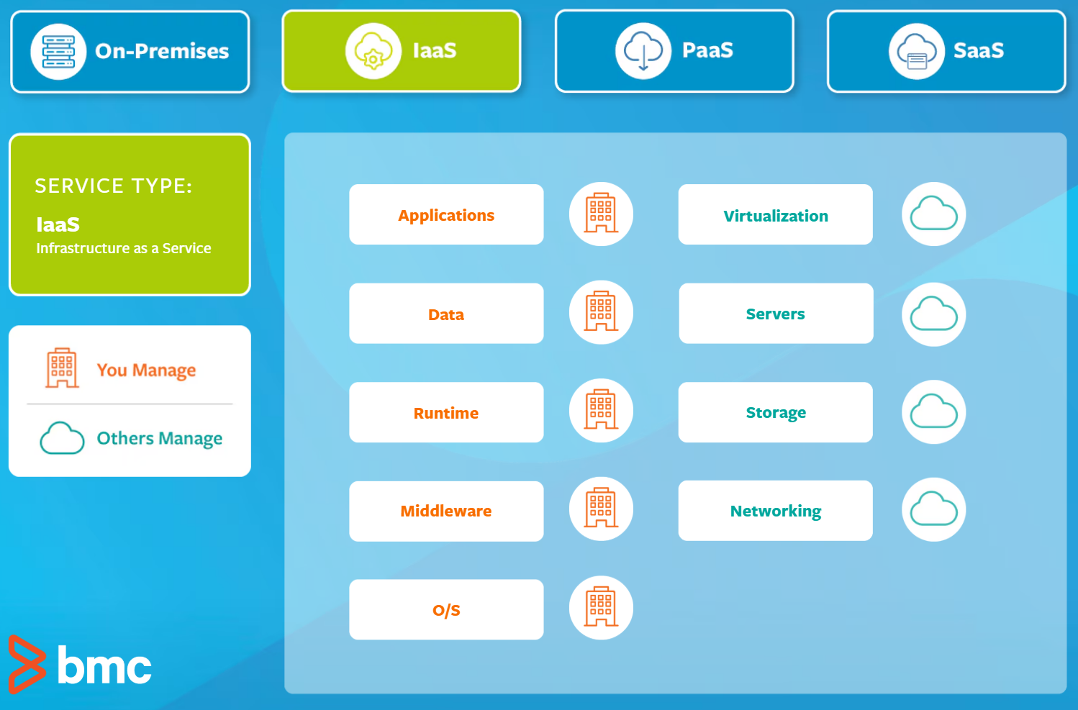

Iaas

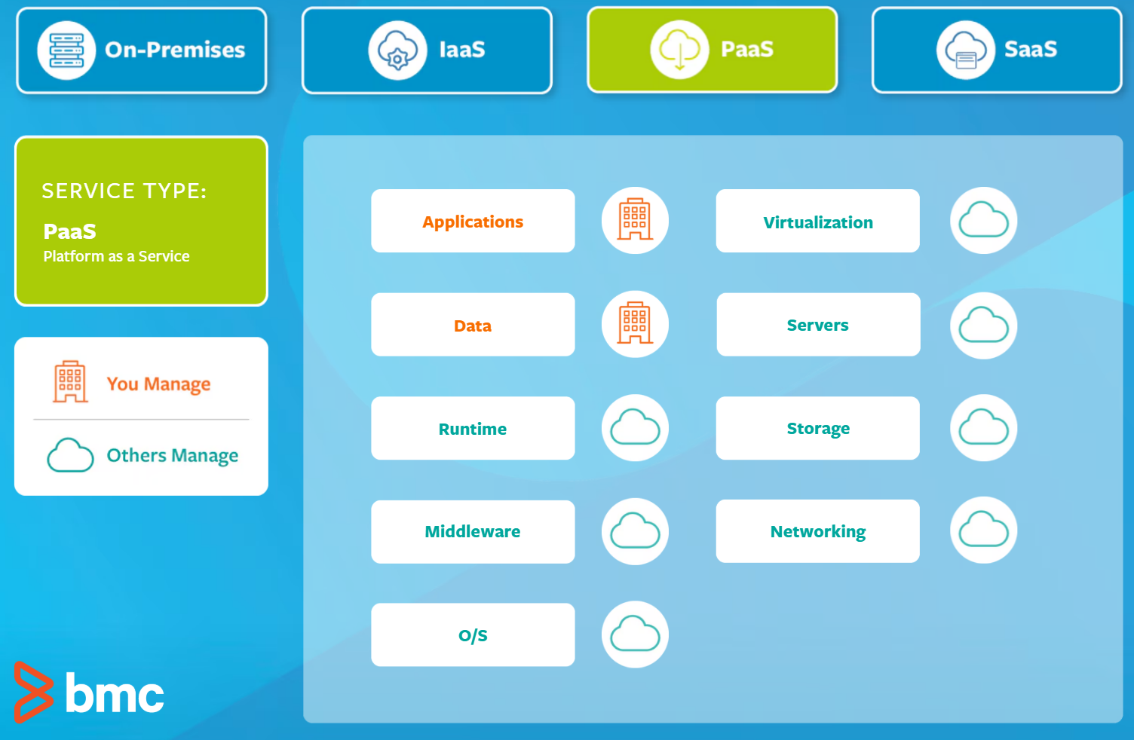

Paas

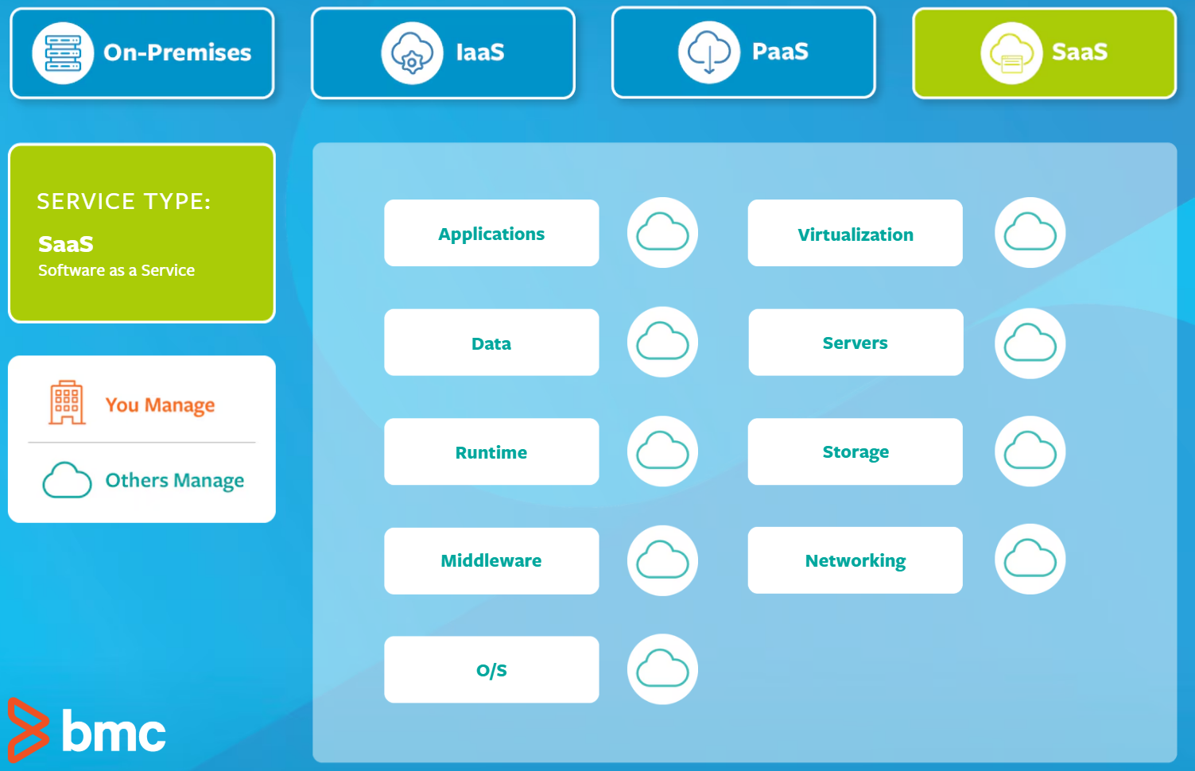

Saas

**pros and cons**

|  |  |
| --- | --- |
| **IaaS pros**   * Highest level of control over infrastructure * On-demand scalability * No single point of failure for higher reliability * Reduced upfront capital expenditures (for example, pay-as-you-go pricing) * Fewer provisioning delays and wasted resources * Accelerated development and time to market | **IaaS cons**   * Responsible for your own data security and recovery * Requires hands-on configuration and maintenance * Difficulties securing legacy applications on cloud-based infrastructure |
| **CaaS pros**   * Ideal for running, managing, and scaling microservices * Streamlined development speeds up time to market * More control and configuration of networks and application components * Increases workload portability between environments, such as hybrid cloud and multicloud * Built-in performance monitoring and container orchestration | **CaaS cons**   * Some CaaS solutions have limited language support available depending on the cloud service provider * Container security risks may increase when using CaaS as they share the same kernel with the OS (although they are considered safer than VMs) |
| **PaaS pros**   * Instant access to a complete, easy-to-use development platform * Cloud service provider is responsible for maintenance and securing infrastructure * Available over any internet connection on any device * On-demand scalability | **PaaS cons**   * Application stack can be limited to the most relevant components * Vendor lock-in may be an issue depending on the cloud service provider * Less control over operations and the overall infrastructure * More limited customizations |
| **SaaS pros**   * Easy to set up and start using * The provider manages and maintains everything, from hardware to software * Software is accessible over any internet connection on any device | **SaaS cons**   * No control over any of the infrastructure or security controls * Integration issues with your existing tools and applications * Vendor lock-in may be an issue depending on the cloud service provider * Little to no customization |